**Our Energy Future**

**Cellulosic Ethanol**

Before hopping into information about cellulosic ethanol, it might be useful to have a refresher on a couple terms.

*Biofuels* – Any renewable, liquid fuels that replace the use of petroleum in internal combustion engines for transportation.

First generation biofuels are those derived from food crops – corn, sugarcane, and oil seeds. Second generation biofuels are those that try to overcome some of the obstacles/limitations associated with first generation biofuels.

Second-generation biofuels use non-food crops (e.g., grassy, herbaceous crops or woody crops) or agricultural residues converted into biofuels.

*Cellulosic ethanol* is ethanol derived specifically from non-food biomass. It can be produced one of two ways - via *thermochemical* or *biochemical* conversions, both of which take the *cellulose* (a chain of hundreds or thousands of carbon, hydrogen and oxygen atoms) from non-food sources and produce a fuel for transportation.

*Biochemical conversion:* Polysaccharides (carbohydrate formed by multiple sugar molecules bonded together) broken down into free sugar molecules which are subsequently used in fermentation. This fermentation then produces ethanol

*Thermochemical:* Feedstock is gasified to produce syngas used either to reform hydrocarbons or in fermentation. This process produces mixed alcohol and hydrocarbons

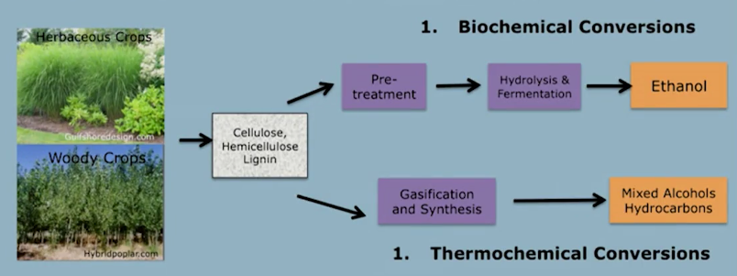

*Why convert cellulose to fuel?*

There are a few reasons why converting cellulose into fuels is an attractive alternative to first generation biofuels:

* Globally abundant, diverse, low cost resource

Can be taken from wood feedstock and forestry residues, agricultural residues, and potentially municipal solid waste sometime in the future

* Limited competition with the food supply and do not raise the price of food
* Low carbon intensity with the potential to be a carbon sink
* Potential for large displacement of petroleum

Wind, solar, etc., are not a viable option to replace liquid fuels used for transportation, but biofuels is one such option

* Starting point for an entirely new and sustainable industry which produce fuels, power, chemicals, feed and fertilizer from renewable resources

In regards to this economic reasoning, there are a few reasons why cellulosic ethanol could make financial sense. The demand for liquid transportation fuels is expected to increase – the global demand for passenger vehicle will increase ~4x by 2050 – and ethanol is already an important portion of the gasoline fuel pool. As the demand for liquid transportation fuel increases, so would ethanol. Cellulosic ethanol is favored over corn ethanol because of its reduced carbon footprint and the lack of the food vs. fuel debate.

Although EVs are making progress in terms of adoption, the vast majority of vehicles rely on liquid transportation fuels. Policies from around the world implement standards which support the use of biofuels such as ethanol, including (but not limited to):

* The EU passed the Renewable Energy Directive requiring 10% of fuels in transport come from renewable sources.
* Through the Bioenergy Five Year Plan, China mandated 5 million tons (1.7b gallons) of biofuel per year by 2015, with that target doubling by 2020.
* India has a target of 20% biofuel in transportation by 2017
* Within the US, the Renewable Fuel Standard (RFS-2) calls for an increasing amount of cellulosic ethanol to fulfill the RFS-2 and be blended in the gasoline pool (up to 60b gallons in 2020, with corn ethanol’s contribution capped at 15b gallons).

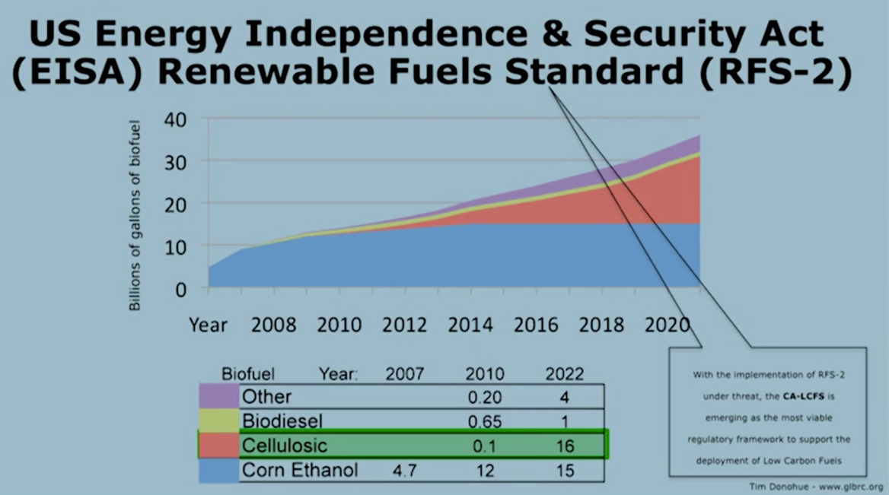

It should be noted that the RFS-2 has come under threat at the time of the videos’ publication, with many oil/gas companies trying to dissuade policymakers from adopting low-carbon fuels.

Another piece of legislation that may yield benefits is the California Low Carbon Fuel Standard, which requires a 10 percent decrease in *carbon intensity* (the amount of carbon released over the amount of energy produced from the combustion of the associated fuel) of the production, distribution, and use of transportation fuels by 2020.

*What components of a plant are important for cellulosic biofuels production?*

Lignin cellulosic biomass is a very complex and diverse *polymer* – a substance that has a molecular structure consisting of chiefly or entirely of a large number of similar units bonded together – made of three main components:

* *Cellulose* – Long chain of glucose molecules that are the main structural component of plant cell walls
* *Hemicellulose ­*– Also form the plant cell walls, but are comprised of different types of sugars than just glucose
* *Lignin* – Polymer that provides biomass its rigidity and resistance to microbial degradation

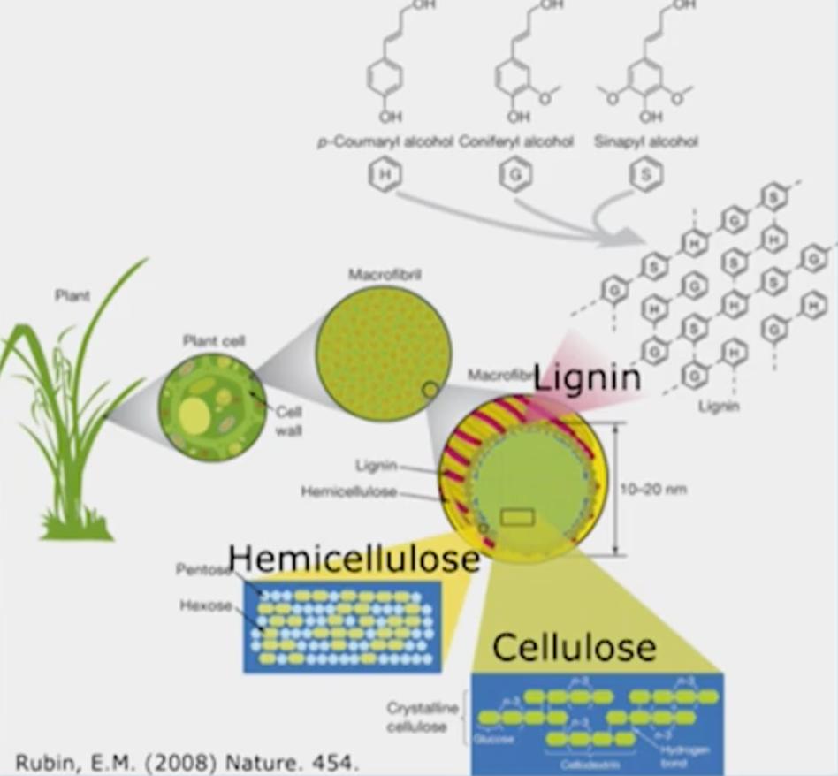

*Types of Cellulosic Feedstocks*

There are many different types of feedstocks that can be used for cellulosic ethanol production:

* Hybrid Poplar trees
* Willow trees
* Eucalyptus trees

Some of the considerations around these three cellulosic feedstocks are that they are fast-growing species that can be grown on either marginal or rich soils; most likely they would be grown on marginal soils because they cannot compete economically with food crops grown on rich soils.

Other sources of cellulosic feedstocks come from herbaceous grasses. The research is at a very early stage in regards to producing cellulosic ethanol from herbaceous grasses

* Sugarcane Bagasse

Used to heat and power processing of sugar to ethanol

* Corn stover

Stalks, leaves and cobs that remain in the field after harvest. Largest source of biomass residue in the US (120 million tons)

* Switchgrass

Mainly in the US. Relatively little biomass lost during harvest, and is possible to fix nitrogen during ethanol production

* Miscanthus

Deep root structures, that demonstrate significant biomass loss during harvest. Capable of fixing nitrogen during ethanol production

*Challenge for Cellulosic Biofuels – Conversion of Cellulose to Ethanol*

The largest challenge for cellulosic biofuels is technical – there is a reason why we make houses out of wood. Nature has formed the various polymers used in cellulosic biofuel production to resist microbial degradation over evolutionary timescales. To deconstruct these polymers into its various elements which can then be converted to biofuels is a significant technological challenge.

The current process to convert cellulose into ethanol is detailed below:

1. A pretreatment phase to make the material such as wood or straw amenable to hydrolysis – this requires softening of the material
2. The cellulose and hemicellulose of these are *hydrolyzed* (reacted with sugar) to break down the long chains of polymers into simple, fermentable sugars
3. The resulting froth is cleaned up to remove the materials not suitable for the downstream processes
4. Microbial fermentation of the sugar solution
5. Distillation to produce roughly 95% pure alcohol
6. Dehydrations by molecular sieves (strainer) to bring ethanol concentration to over 99.5%

Note that *only* steps 1 through 3 are unique to cellulosic biofuel production; steps 4 through 6 are steps shared by current biofuel processes from corn and other food crops.

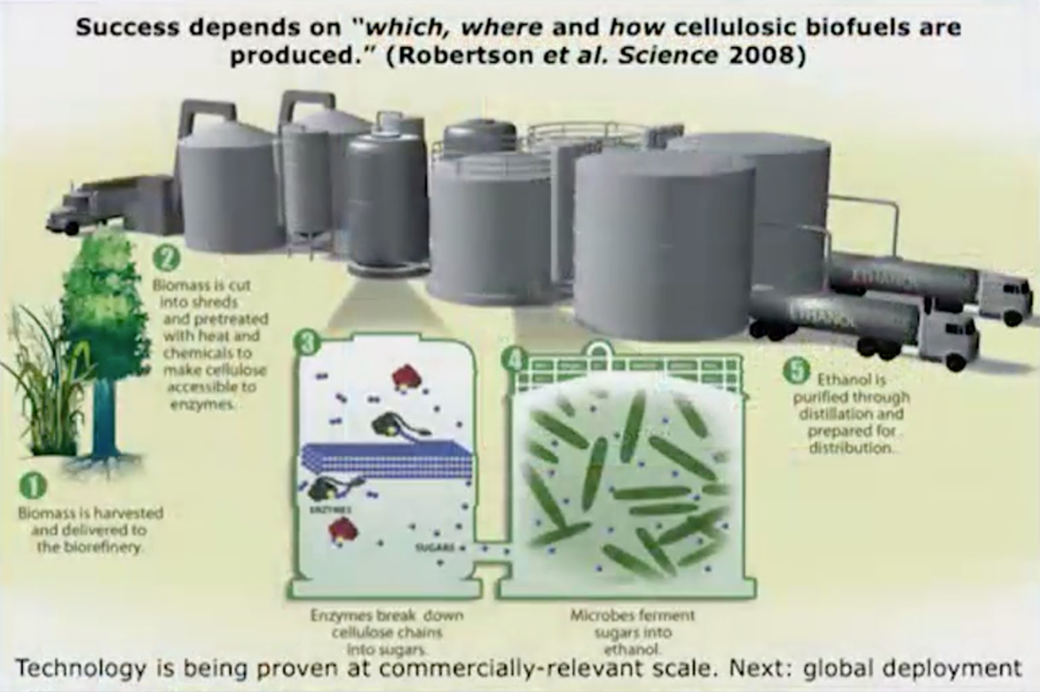Step 2 previously was extremely expensive to perform – in ~2007 it cost roughly $5/gallon to undergo just this step. By the time of recording (~2013), the cost had dropped to $0.60/gallon due to intensive R&D, with expected cost to drop further to ~$0.40/gallon by 2017.

*Reduction of CO2 emissions with cellulosic ethanol production*

When looking at the net reduction of CO2 emissions in comparison to petroleum gasoline, the table below summarizes how each source of ethanol performs:

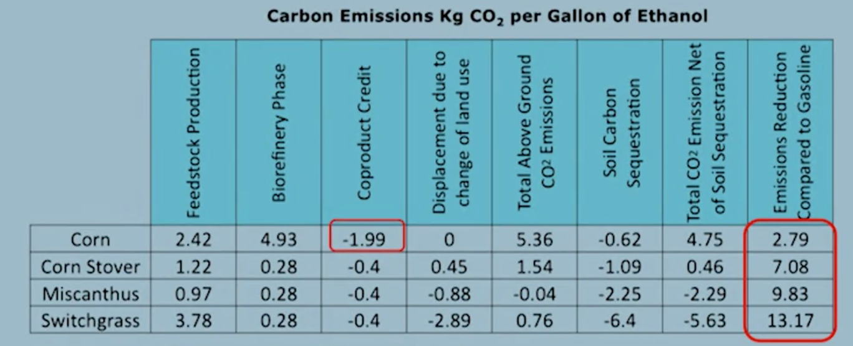

Emissions from gasoline are 7.54 kg CO2 per energy equivalent gallon of ethanol. When produced with miscanthus or switchgrass, cellulosic ethanol can act as a net carbon sink due to the carbon that is sequestered in the roots of those crops.

*Summary and Conclusions*

* Biofuels are one of the only scalable and sustainable options to displace petroleum use
* Cellulosic ethanol has solid environmental credentials: low carbon intensity, limited competition with food supply
* Technology has begun to be commercially proven at scale
* After 20+ years and hundreds of millions of dollars spent on R&D, the first version of the technology is cost competitive with petroleum refining on an operating basis

The large capital requirements still pose a challenge for global and large-scale increase in deployment of the technology. Because of this, policy support is still needed for 3-5 years

* Substantial opportunities for further improvements to the technology’s competitiveness going forward

As examples, more sources of biomass could be incorporated into the production process, or the biocatalysts could be improved. The cash flows from the existing technology could help fund this R&D

* With the technology viability (technical and economic) out of the way, the focus becomes laying the foundation for a large-scale, global yet sustainable industry

Perhaps the most significant obstacle to cellulosic ethanol adoption is developinh local, replicable and cost-effective biomass supply chains to get cellulosic ethanol from the plants to the end products consuming the ethanol.

* Large, well-capitalized companies are replacing venture-funded start-ups

This is a sign of a maturing industry gearing up for deployment. The players in this market have committed resources and are now consolidating the industry to form partnerships